1. Run flask app
   1. export FLASK_APP = app.py
   2. flask run
2. 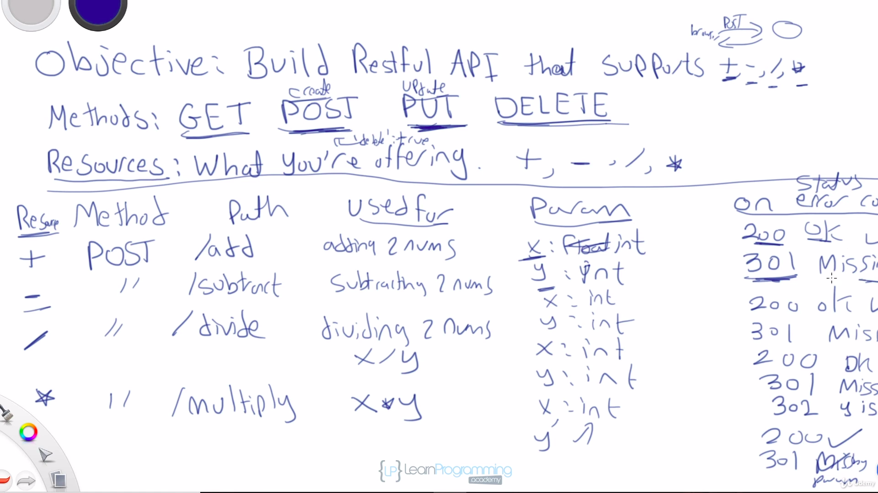
3. <https://flask.palletsprojects.com/en/2.2.x/>
4. <https://flask-restful.readthedocs.io/en/latest/>
5. To install Docker Engine, you have to follow this link for Ubuntu: <https://docs.docker.com/engine/install/ubuntu/>
6. <https://docs.docker.com/compose/install/linux/>
7. 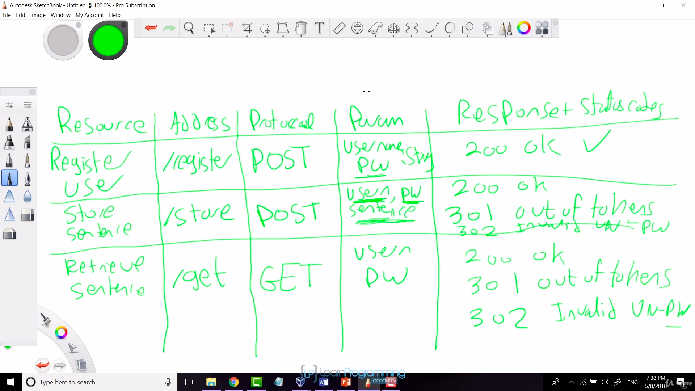
8. **systemctl status docker.service**
9. **sudo docker-compose build**
10. **sudo docker-compose up**

**13.**

